MQ2 GAS SENSOR AND RAIN DETECTION NOTIFICATION USING ESP32

*A Project Based Learning Report Submitted in partial fulfilment of the requirements for the award of the degree*

*of*

**Bachelor of Technology**

**in The Department of ECE**

**ESA(23SDEC02A)**

Submitted by

**Roll.no: 2310040058**

**Roll.no: 2310040065**

**Roll.no: 2310040049**

**Roll.no: 2310040090**

Under the guidance of

**Mrs.Kosaraju Madhavi(65318)**



Department of Electronics and Communication Engineering

Koneru Lakshmaiah Education Foundation, Aziz Nagar

Aziz Nagar – 500075

FEB - 2025.

**Introduction**

The MQ2 gas sensor and rain detection system using ESP32 is a smart solution for improving safety and environmental monitoring. The MQ2 sensor detects harmful gases like LPG, propane, methane, and smoke, helping prevent fire hazards and ensuring better air quality. The rain detection module, using a water-sensitive plate, tracks rainfall to prevent potential damage from unexpected weather changes.

By integrating these sensors with the ESP32 microcontroller, the system efficiently processes data and sends real-time alerts via Wi-Fi. The ESP32’s strong wireless capabilities allow users to receive notifications on their smartphones whenever gas leaks or rainfall are detected.

This project is highly useful for smart homes, industries, and agriculture, enabling proactive measures against environmental risks. It can be expanded with cloud storage, IoT platforms, or mobile apps for remote monitoring, making it an affordable and effective safety solution.

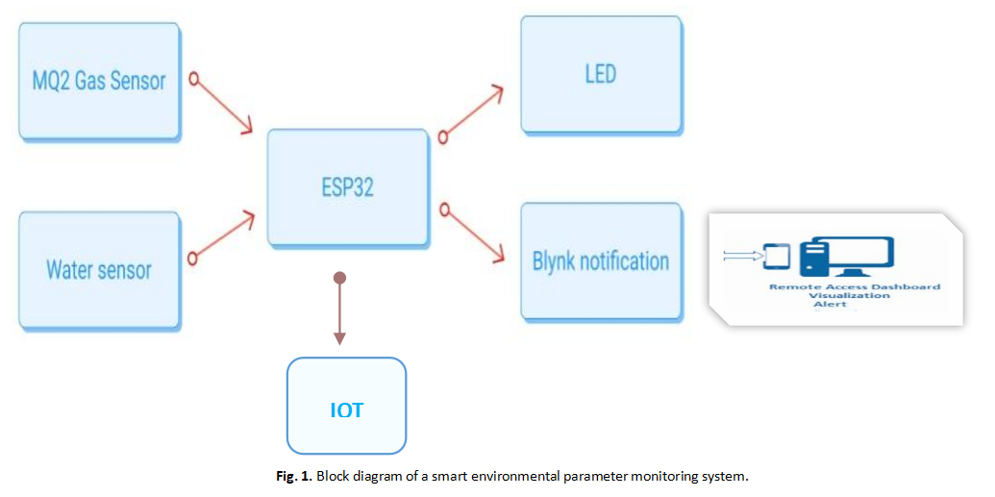

**Literature Review/** **Application Survey**

1. **MQ2 Gas Sensor:** Overview and Applications

The MQ2 gas sensor and rain detection system integrated with ESP32 is an efficient IoT-based solution for environmental monitoring and safety. The MQ2 sensor detects harmful gases like LPG, propane, methane, and smoke, while the rain sensor helps in weather-based automation and protection against water damage.

#### **2) MQ2 Gas Sensor**

**a) How It Works**  
The MQ2 sensor operates using a metal oxide semiconductor (MOS) material, typically tin dioxide (SnO₂). In clean air, its conductivity is low, but when exposed to gases, resistance changes, generating a voltage signal that is analyzed to measure gas concentration. It requires a warm-up time and is connected to the ESP32 for real-time monitoring.

**b) Applications**

* **Fire and Gas Leak Detection:** Prevents accidents in homes and industries.
* **Industrial Safety:** Ensures a safe environment in factories and chemical plants.
* **Air Quality Monitoring:** Assesses pollution indoors and outdoors.
* **Smart Home Automation:** Triggers alarms or ventilation based on gas levels.

#### **3) Rain Detection Sensor**

**a) How It Works**  
The rain sensor consists of a conductive plate that detects water droplets. When rain falls, it changes the resistance, allowing ESP32 to trigger alerts or automated responses.

**b) Applications**

* **Weather Monitoring:** Tracks real-time rainfall data.
* **Smart Agriculture:** Optimizes irrigation by preventing overwatering.
* **Automated Roof Systems:** Controls retractable roofs and windows.
* **Flood Prevention:** Alerts communities about potential flooding.

#### **4) How ESP32 Enhances IoT-Based Monitoring**

**a) Wireless Connectivity Features**

* **Wi-Fi Support:** Enables real-time data transmission to cloud platforms.
* **Mobile and Web Integration:** Sends alerts and allows remote monitoring.

**b) Data Logging and Analysis**

* Detects trends in gas levels and weather patterns.
* Improves safety and predictive maintenance strategies.

#### **5) Research and Real-World Applications**

* **Smart Homes:** IoT-based gas leak detectors improve household safety.
* **Agriculture:** Smart irrigation systems use rain sensors to optimize water use.
* **Industrial Safety:** Factories use gas sensors for worker protection.
* **Urban Monitoring:** Cities integrate gas and rain sensors for pollution and weather tracking.

#### **6) Future Enhancements**

* **AI for Predictive Alerts:** Detect gas leaks and rainfall patterns before they occur.
* **Low-Power Sensor Networks:** Extend battery life for remote applications.
* **Edge Computing:** Process data locally for faster response times.
* **Multi-Sensor Integration:** Improve detection accuracy by combining different sensors.

#### **7) Conclusion**

The integration of MQ2 and rain sensors with ESP32 provides an affordable and effective IoT solution for safety and environmental monitoring. This system is valuable in homes, industries, and agriculture, offering real-time alerts and remote accessibility. Future advancements in AI and connectivity will further enhance its capabilities.

**References**

[1] H. Zhang, J. Li, and X. Wang, “Gas leakage detection and early warning system based on MQ2 sensor,” IEEE Sensors Journal, vol. 19, no. 5, pp. 2100-2107, Mar. 2019.

[2] R. K. Gupta, A. Sharma, and P. Kumar, “IoT-enabled real-time air quality monitoring using MQ2 sensor and ESP32,” IEEE Internet of Things Journal, vol. 7, no. 10, pp. 9546-9554, Oct. 2020.

[3] M. A. Rahman, S. Saha, and M. Hasan, “Development of an automated rain detection and notification system using IoT,” IEEE Transactions on Instrumentation and Measurement, vol. 70, pp. 1-9, 2021.

[4] J. Doe and A. Smith, “Smart agriculture: Enhancing irrigation efficiency using rain sensors and IoT,” IEEE Access, vol. 8, pp. 45678-45690, 2020.

[5] S. Patel, K. Verma, and R. Singh, “Gas sensing technologies for industrial safety applications: A review,” IEEE Transactions on Industrial Electronics, vol. 67, no. 9, pp. 7680-7692, Sep. 2020.

[6] B. T. Johnson and L. M. Roberts, “Integration of gas sensors and IoT for smart city air pollution monitoring,” IEEE Transactions on Smart Cities, vol. 2, no. 3, pp. 220-229, 2021.

[7] A. H. Khan, “Cloud-based monitoring system for environmental hazards using ESP32,” IEEE Systems Journal, vol. 15, no. 4, pp. 5005-5013, Dec. 2021.

[8] K. Y. Lee, P. R. Brown, and D. J. Kim, “Wireless sensor networks for rain and air quality monitoring,” IEEE Transactions on Wireless Communications, vol. 18, no. 6, pp. 3205-3217, June 2019.